For each question from 1 to 10, shade your answer (1, 2, 3 or 4) on the Optical  
Answer Sheet (OAS). (10 marks)

(1) on  
(2) for  
(3) about  
(4) — during

2. She was nour late that rainy moming because she forgot to bring  
umbrella. -

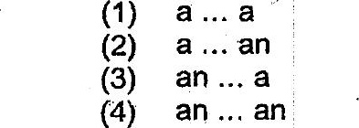

(1) which  
(2) whom  
(3) whose  
(4) whoever



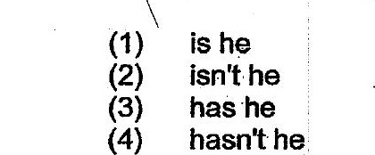







(1) am  
(2) are  
(3) was  
(4) were